Screenshot Lab11

1. 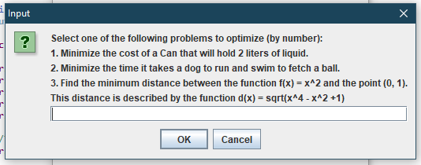

Function 1 :

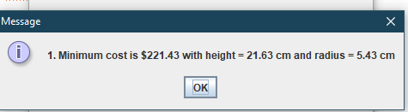

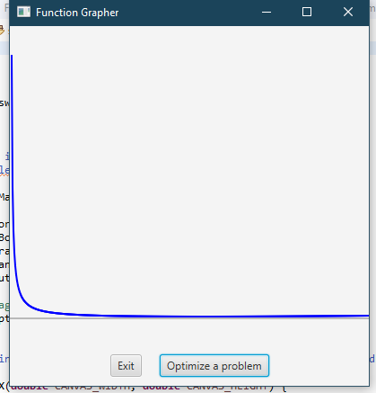

1. Function 2 :
2. 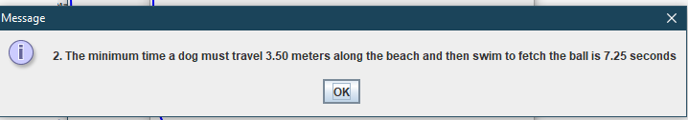

Graph of a function 2

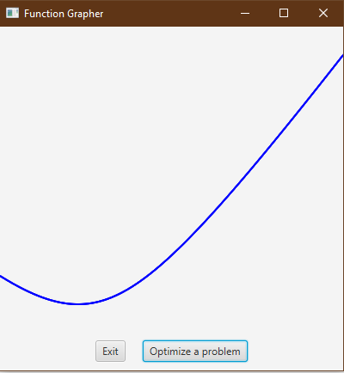

Function 3rd :

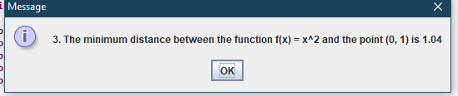

Graph of function 3rd

